**Step1:** Click on Products -> Category

Here You can create a brand new Category or you can add Subcategory to the default category.

Click on Add Subcategory button and fill the details as shown below. Here we can define the category related configurations like store, display in menu, page layout of the category, URL keys, SEO info etc

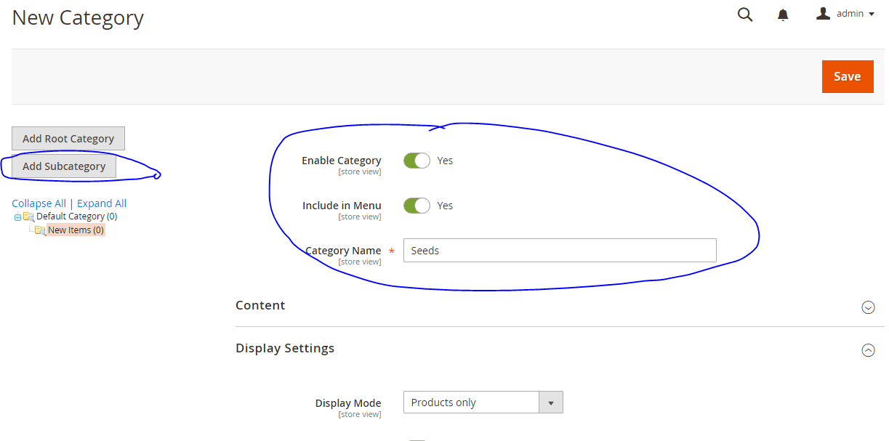

Created categories will display on the home page of the website as a menu. Click each menu items to elaborate more.

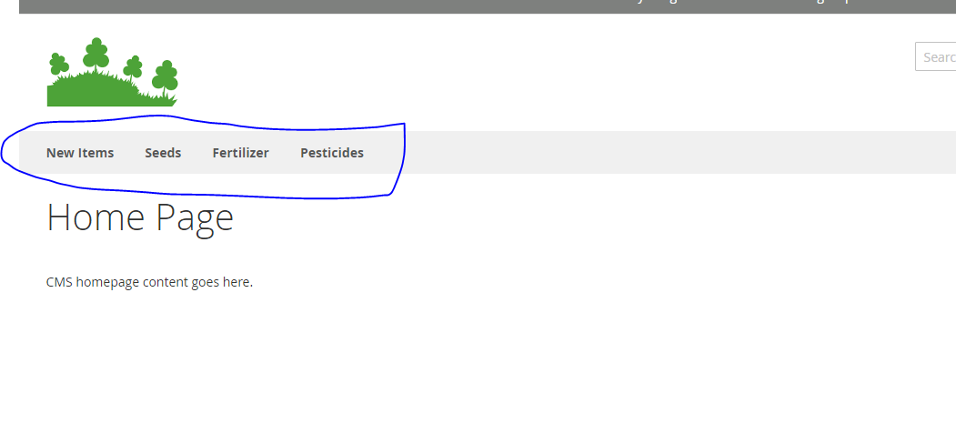

**Step2:** Add product to category

Click on Products🡪 Catalog in the left navigation menu as shown below.

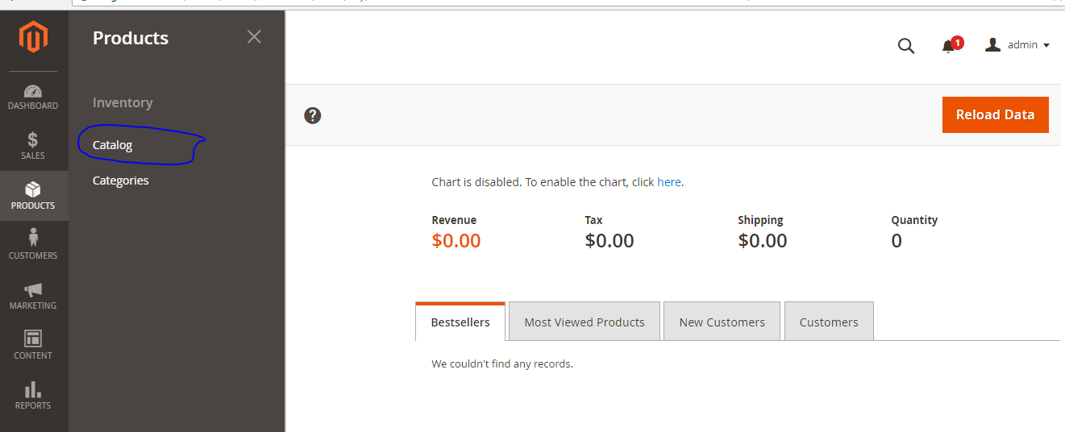

It will navigate product creation screen. Fill the details carefully which includes product name, image, price, stores, tax rules, inventory, weight visibility and under which category product display fill these details and click on save.

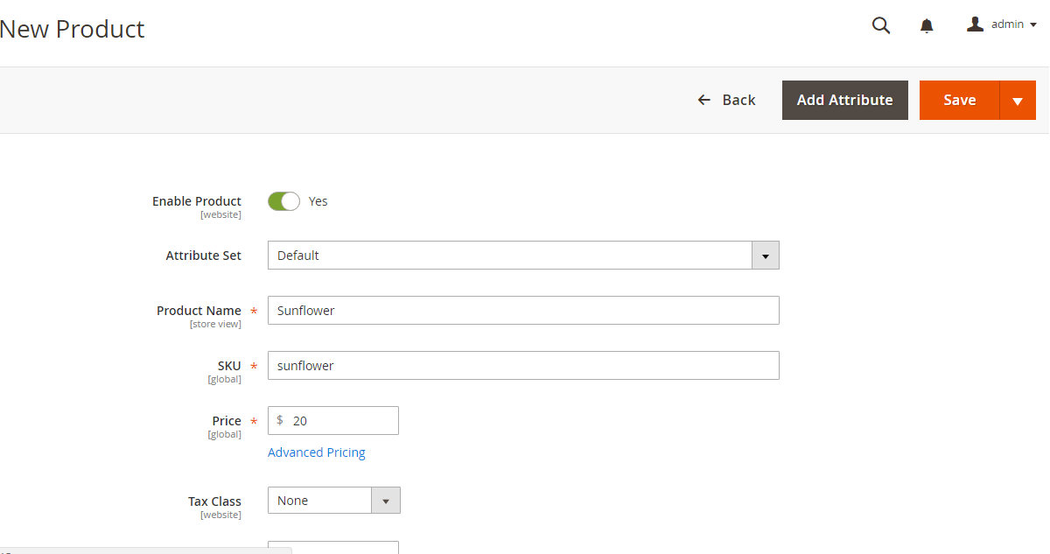

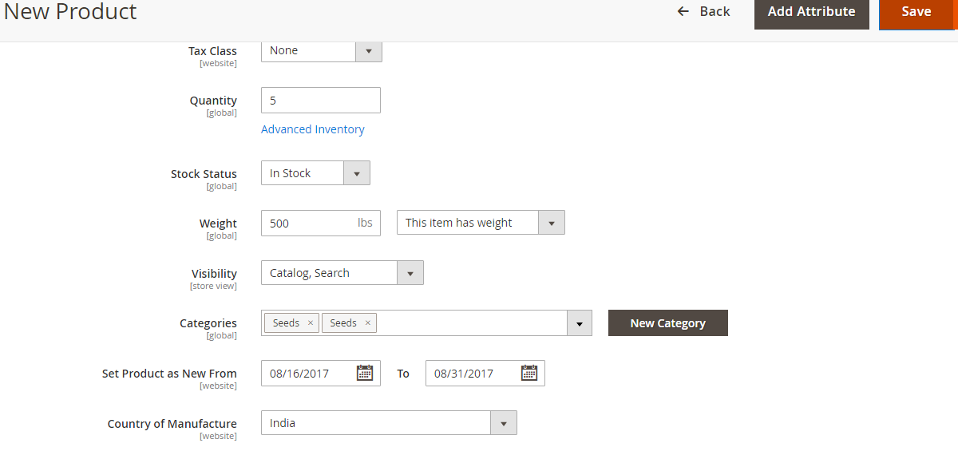

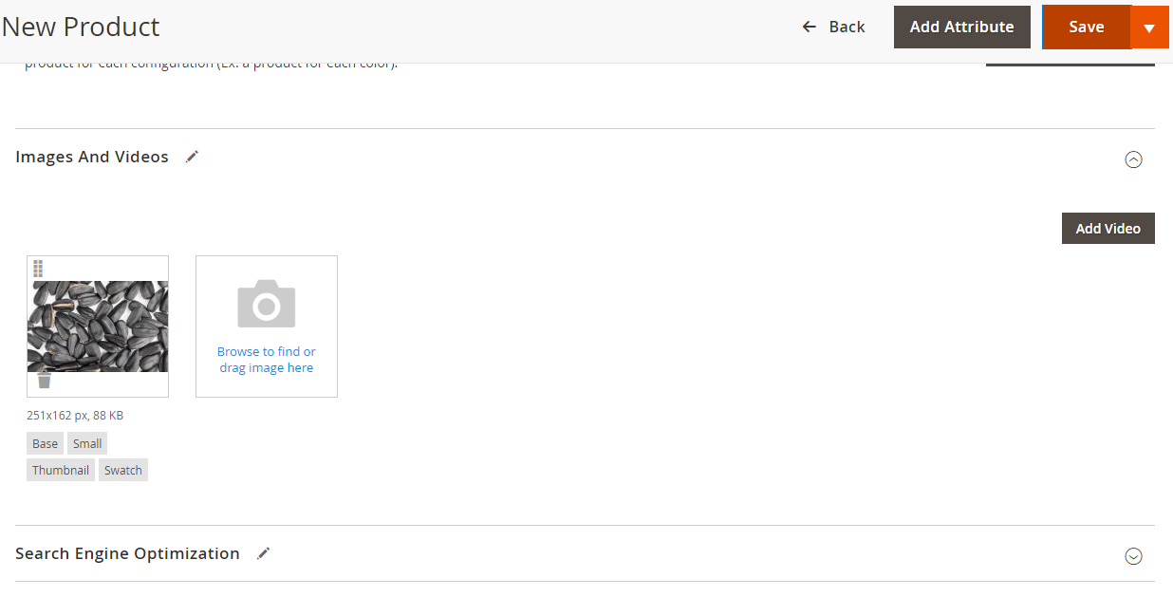

Once the product is created it will display on catalog list as well as on the site under the category you have created.

